Alexander Baldree
07/28/26
Module 11.2 Assignment- Coding Standards
CSD430

As I continued learning about programming, I started to realize that getting a program to run is only one part of writing good code. When I first began working with Java, I was mostly focused on whether the program compiled and produced the correct output. As projects became larger and I started using multiple classes, JavaBeans, JSP pages, databases, Maven files, and GitHub repositories, organization became much more important. A small naming mistake or an unclear section of code could cause me to spend more time trying to understand my own work than it took to write it. Coding standards are meant to prevent these problems by giving developers a shared set of rules to follow.

Coding standards are documented rules that explain how developers should write, format, organize, test, secure, and document source code. Some standards apply to a programming language, while others are created by a company for its own projects. Google maintains standards for Java, JavaScript, TypeScript, HTML, CSS, and other languages. Google describes its Java guide as “the complete definition of Google’s coding standards for source code in the Java Programming Language.” Its guide covers file names, encoding, formatting, braces, naming, comments, and the organization of Java classes.
Other languages have their own recognized standards. Python developers commonly use PEP 8, which was created to make Python code more readable and consistent. PEP 8 explains that “code is read much more often than it is written.” It also points out that consistency within the current project may be more important than blindly applying every general rule. Microsoft provides similar conventions for C# projects. Its guidelines address naming, indentation, comments, exception handling, language features, and writing code with clarity and simplicity. Microsoft explains that consistent code is “easier to understand, maintain, and extend.”
The standards followed by a corporation may go beyond appearance. A style guide may say that a Java class uses PascalCase, methods and variables use camelCase, constants use uppercase letters, and each indentation level uses a specific number of spaces. A secure coding standard may explain how developers should validate input, manage memory, handle errors, protect credentials, and avoid unsafe programming functions. The SEI CERT standards include secure coding guidance for languages such as C, C++, Java, and Perl. These standards are developed with contributions from software development and security professionals.
Documentation is another important part of coding standards. The documentation requirements provided for this course explain that each source file should contain the programmer’s name, date, assignment information, and a short statement describing the purpose of the code. The requirements also call for descriptive variable and method names, comments where the purpose is unclear, proper indentation, blank lines between sections, and credit for borrowed or generated code. One suggestion compares the organization of source code to writing by saying, “Think of sections of code as paragraphs in an essay.” That comparison makes sense to me because one large block of code is just as difficult to follow as an essay written as one giant paragraph.

In the corporate programming world, standards give an entire development team a common way to work. Without them, one developer may use tabs while another uses spaces. One person may name a variable customerAccountNumber, while another may call the same type of value can, number1, or data. The program might still run, but the inconsistency makes the project harder to read. When several developers work in the same repository, every person should be able to open a file and understand its basic structure without first learning the personal habits of the person who wrote it.
Naming standards are one of the simplest examples. A descriptive method named calculateOrderTotal() gives me a clear idea of what the method does before I read its contents. A method named doIt() does not provide the same information. The same principle applies to variables. A name such as failedLoginAttempts is more useful than x because it explains what information is being stored. This becomes even more important when I return to a project after several weeks and no longer remember every decision I made.
Formatting standards help developers recognize the structure of the program. Indentation shows which statements belong to a class, method, loop, or condition. Blank lines separate different ideas, and consistent brace placement makes it easier to see where a block begins and ends. Google’s Java standards, for example, require spaces instead of tabs for indentation and provide specific rules for the structure of Java source files. Python’s PEP 8 recommends four spaces for each indentation level and provides guidance for line breaks, imports, whitespace, comments, and naming.
Comments and documentation are also used to preserve information that the code cannot clearly explain on its own. From my experience, comments are most useful when they explain why something is being done instead of repeating the statement directly below them. A comment such as // Increase count by one above count++ does not add much value. A comment explaining that a temporary calculation is required because of a database limitation gives the next developer useful context. Public classes and methods may also use formal documentation such as Javadoc so that other developers know what inputs are expected, what the method returns, and which errors may occur.
Corporations can enforce these standards through code reviews and automated tools. Instead of depending on every developer to remember every rule, teams can configure IDE formatters, linters, static-analysis tools, and continuous integration pipelines. Microsoft explains that teams can use .editorconfig files and code analysis to apply company-wide, team-wide, or project-specific rules. A continuous integration build can then warn the team when submitted code violates one of those rules. This allows the reviewer to focus more on whether the code works correctly instead of spending the entire review pointing out missing spaces or incorrectly placed braces.

The main reason coding standards matter is that corporate software normally lasts longer than the person who originally wrote it. Employees change positions, teams expand, requirements change, and applications receive updates for years. A developer may create a feature today, but another person may be responsible for repairing it several years later. When the code follows a consistent standard, that next developer has a better chance of understanding it without rewriting everything.
Coding standards can also reduce mistakes. Clear names and smaller methods make incorrect logic easier to notice. Consistent error handling makes it less likely that an important failure will be silently ignored. Microsoft recommends catching only exceptions that can actually be handled and using specific exception types that provide meaningful information. Secure coding rules can reduce the chance of vulnerabilities by requiring developers to validate input, protect sensitive information, and avoid dangerous programming practices.
These standards also support testing and code review. A reviewer can compare a proposed change against an agreed set of rules instead of judging the code entirely through personal preference. This makes the review fairer and more useful. The developer knows what is expected before submitting the code, and the reviewer has a written reason for requesting a change. When the same standards are connected to automated tests and repository controls, poorly formatted, insecure, or incomplete code can be stopped before it is merged into the main branch.
Coding standards are not meant to remove creativity from programming. They create a dependable structure where developers can focus their creativity on solving the actual problem. A company does not need every team to use the same rules as Google, Microsoft, or Python. It needs rules that make sense for its languages, projects, security requirements, and employees. Once those rules are selected, they should be documented, taught, reviewed, and enforced consistently.
As I have worked through larger programming assignments, I have learned that readable code saves time. A program may run correctly today, but that does not automatically make it good corporate code. Good code should be understandable, maintainable, testable, secure, and properly documented. Coding standards help turn source code from one person’s solution into something an entire team can continue using.

Code That Does Not Follow Clear Standards

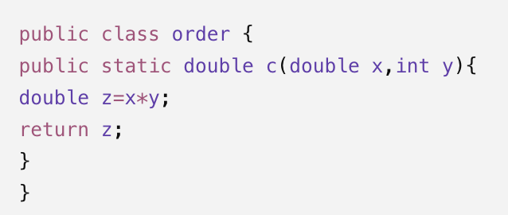
The problem with this includes the lowercase class name, unclear method and variable names, missing documentation, and inconsistent formatting.

The Same Code Using Clearer Standards

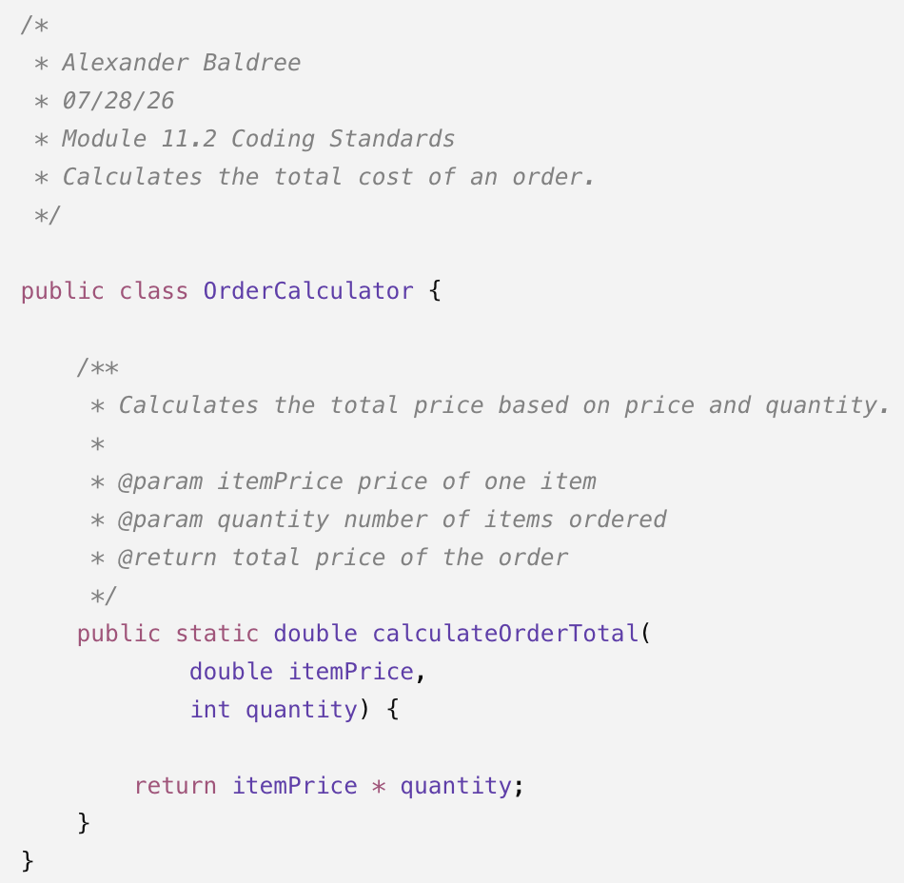

Clear Exception Handling
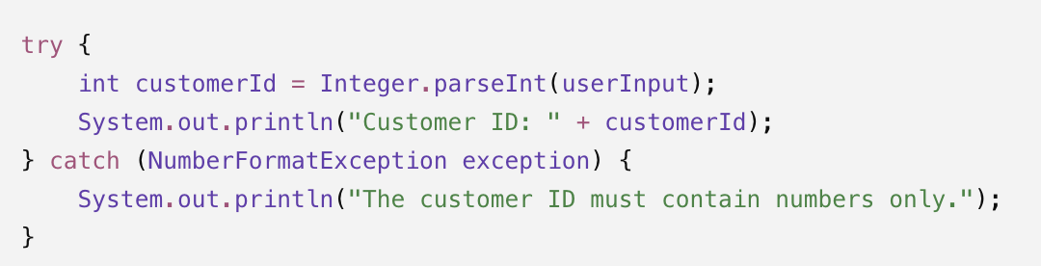
This catches the specific problem that can occur instead of catching every possible exception.

References
Carnegie Mellon University Software Engineering Institute. (2024). SEI CERT coding standards. https://www.sei.cmu.edu/blog/the-sei-cert-coding-standard-for-fortran/
Google. (n.d.). Google Java style guide. https://google.github.io/styleguide/javaguide.html
Microsoft. (2025). Common C# code conventions. Microsoft Learn. https://learn.microsoft.com/en-us/dotnet/csharp/fundamentals/coding-style/coding-conventions
Van Rossum, G., Warsaw, B., & Coghlan, A. (2001). PEP 8—Style guide for Python code. Python Software Foundation. https://peps.python.org/pep-0008/

